BIT 4107 – MOBILE APPLICATION DEVELOPMENT
ENHANCED PROFESSIONAL STUDENT LOGBOOK
STUDENT NAME: SHALOM KIBOKO
ADMISSION NUMBER: BIT/2025/39237
SCHOOL/FACULTY: COMPUTING AND INFROMATICS
PROGRAMME: BACHELOR OF SCIENCE IN INFORMATION TECHNOLOGY
ACADEMIC YEAR: 2
SEMESTER: 2
LECTURER: MR.NYORO MICHAEL
PHONE NUMBER: 0725865117

WEEK7:

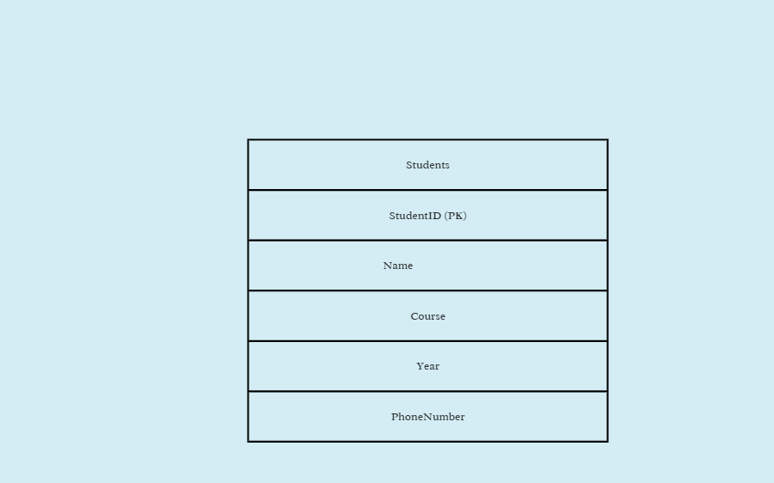
Task 2: Student Database Design

Primary Key: StudentID
StudentID is the primary key because it uniquely identifies each student record.
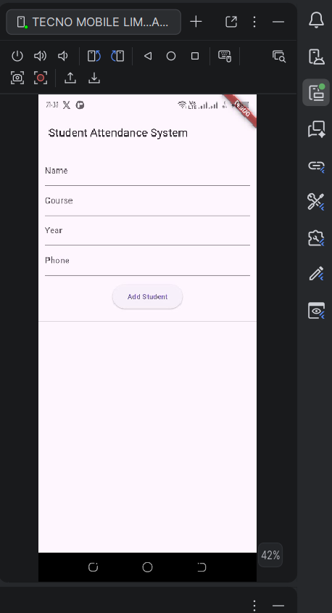
Task 3: Mini Project

Figure 1: Student Registration Form

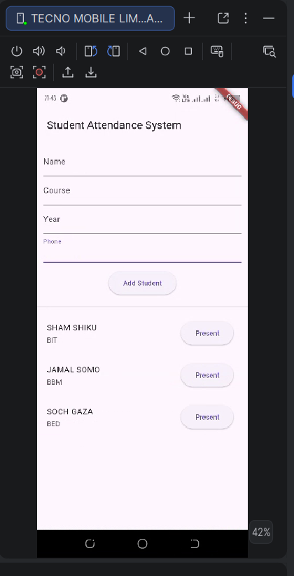

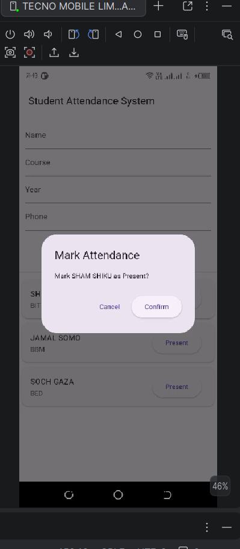
Figure 2: Registered Students

Figure 3: Mark Attendance

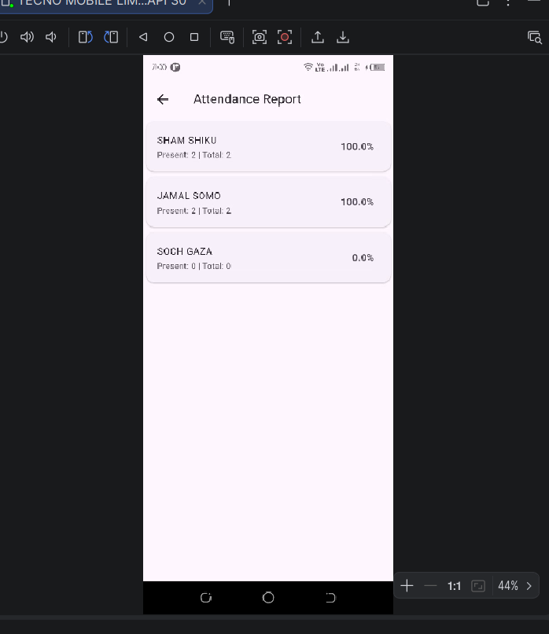

Figure 4:Attendance Report

